**Assignment-2**

**Location Trails**

Name- yashika gola

Roll on-47

**Location Trails or tracking**

Location tracking refers to technologies that physically locate and electronically record and track the movement of people or objects.

Location tracking technology is used every day. We use location tracking for navigation through GPS, searching for restaurants, cafes, businesses nearby using common apps.

**GPS(Global Positioning** **System)**

The Global Positioning System (GPS) is location tracking technology. The data from 24 satellites orbiting the earth is collected and is used to locate the location of an object or person. A GPS satellite calculates location by timing how long it takes a radio signal traveling to reach either a fixed or mobile tracking device on earth such as a GPS navigation device built into your smartphone with a GPS chip.

Using multiple satellites, a GPS device can identify it's longitude and latitude location and display the information to the person using the device or send the information to a software app or program.

**How is location tracking used?**

Some GPS devices don't send your location anywhere, they just record your location and keep a record of where you are and what was your location at particular time.

Your “Location history” option is a list of locations you've traveled. I have attached a link of my location history. Google saves your location history. You can retrieve the locaton history or other data from the google when you need that.

https://drive.google.com/open?id=12oC8CfXuUWvKR_k-7DDGMWLsa8jKCFOe

Facebook is a widely known app that uses your location when your check-in using the Facebook app on a smartphone.

**Uses**

Location tracking has many beneficial uses. location tracking, traffic jams of vehicles, and product shipments and many more.

Using a device like a smartphone along with a map app to help you find directions, learn about nearby businesses and facilities, and help navigate are useful reasons to allow an app to know your location.

**Current Location of my device:**

The HTML Geolocation API is used to locate a user's position.

**CODE**

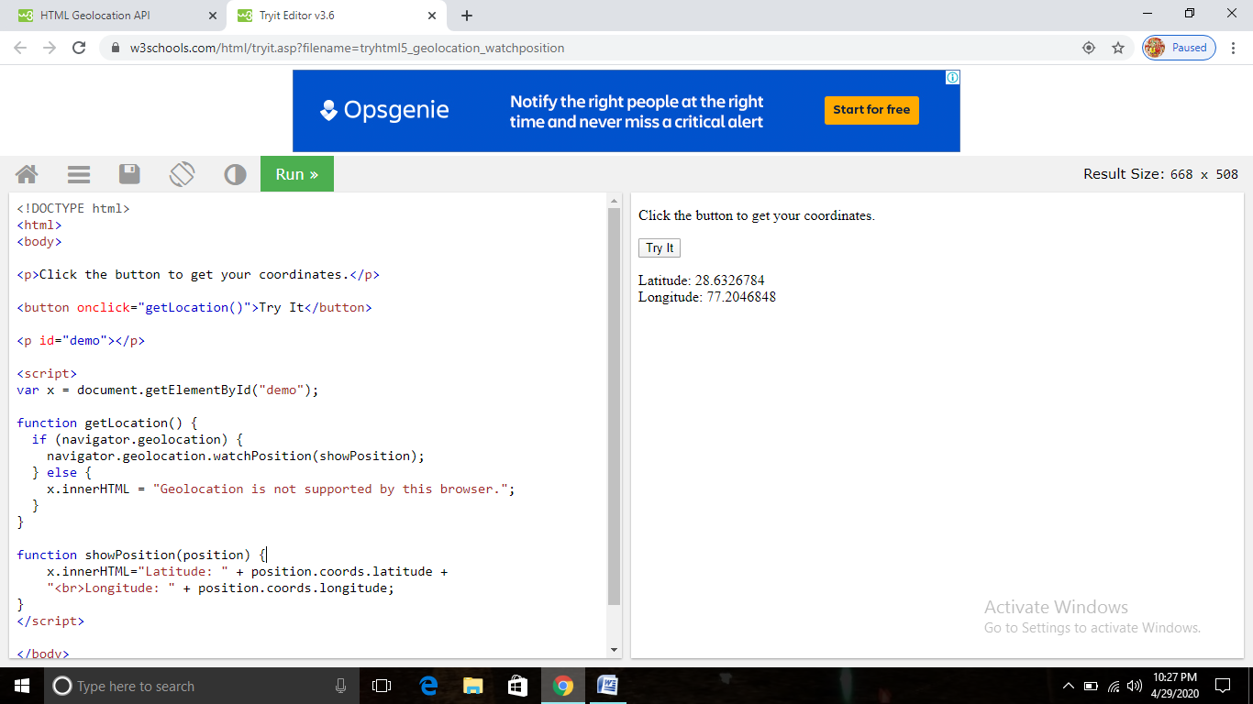

Code Explained:

* Check if Geolocation is supported
* If supported, run the getCurrentPosition() method. If not, display a message to the user
* If the getCurrentPosition() method is successful, it returns a coordinates object to the function specified in the parameter (showPosition)
* The showPosition() function outputs the Latitude and Longitude

**OUTPUT**

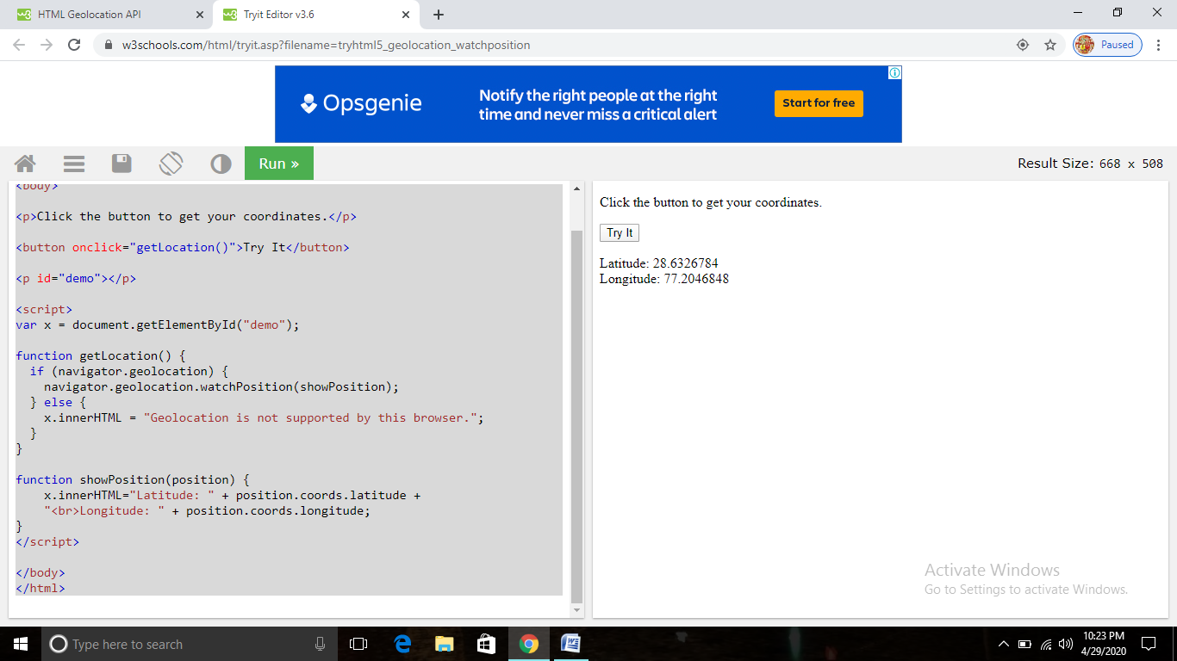

**Location Trail**

Code of location trail is in pdf send along with this document.